Week: 5  Period: 13 | UNIT 2: CITY LIFE  Lesson 5: Skills 1 | DOP: 5/10/2025  DOT:

A. OBJECTIVES
By the end of this lesson, Ss will be able to:
I. Knowledge:
Read for main idea and specific information in an article about a competition to find solutions to city problems
II. Competences:
Talk about city problems and their solutions
III. Personal qualities
- Be aware of city problems and their solutions
B. TEACHING AIDS
- Teacher: Grade 9 textbook, smart TV, visual aids, sachmem.vn
- Students: Textbooks, notebooks
C. PROCEDURES
I. WARM-UP Network/brainstorming
* Aims: To create an active atmosphere in the class before the lesson and lead into the new lesson.
- Ask the students to give some problems in the cities, T gives an example.
- Students work in 2 teams, which team give more suitable ideas will be the winner
problems in the cities
dirty streets

Suggest answer: dirty streets, lack of playing spaces for children, air pollution, accidents, traffic jams,…..
II. PRE-STAGE
* Aim: - Teacher introduces the vocabulary.
- Teacher explains the meaning of the new vocabulary, using pictures and translation, and Match the words / phrases with their pictures
a) Vocabulary
- leftover (n): /ˈleftəʊvə(r)/: thức ăn thừa {picture}
- biogas (n): /ˈbaɪəʊɡæs/ khí sinh học {picture}
* Check vocabs: What and where
Act. 1: Work in pairs. Match the words / phrases with their pictures.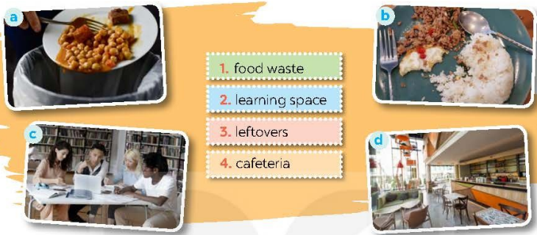
- T asks Ss to work in pairs and match the given words/phrases with the pictures.
- T Checks the answers as a class.
- Ss do exercise in pairs.
Answer key: 1. a 2. c 3. b 4. d
III. DURING- STAGE
* Aim: To improve Ss’reading skill for specific information.
Act. 2: Read part of an announcement about the Teenovator competition. Match the topics in the competition with their winners.
- Teacher tells Ss to work individually to read part of an announcement about the winners of the
Teenovator competition
- Teacher asks Ss to match the topics in the competition with their winners, then share their answers with the class.
- Teacher invites some students to write their answers on the board. Have other Ss explain their answers. Confirm the correct answers.
Answer key: 1. C 2. B 3. A
Act. 3: Read the announcement again. Choose the correct answer
- Have Ss read the text in detail first. Then ask them to read each question and choose the correct answer for it. - Ask ss to find the information in announcement.
- Call on Ss to share their answers. Ask them where they find the information for their answers
- Confirm the correct answers as a class. Explain if needed.
Answer key: 1. A 2. D 3. B 4. C 5. A
IV. POST-STAG: SPEAKING
* Aims:
- To help Ss prepare ideas for the next activity.
- To provides an opportunity to practise presenting about the city problems & suggest solutions

Act. 4: Make a list of city problems and some solutions to them.
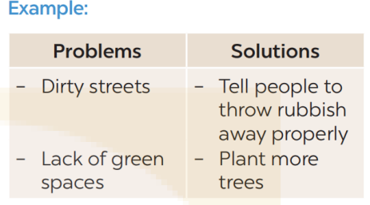
- T asks Ss to work in pairs and add as many details of problems of city life and solutions in the mind map as possible. Alternatively, Ss can use problems given in the textbook & think of solutions to them
- T asks pairs to share their answers with the class.
- Ss add details of problems of city life and solutions in the mind map.
Suggested answer:
Problems | Solutions
Traffic congestion | Encourage people to use public transportation and cycling.
Air pollution | Implement tree-planting programs, create green spaces.
Waste management issues | Promote recycling programs.
Homelessness | Offer temporary housing and job training for homeless people.
Unemployment | Provide job training programs, and support small businesses and start-ups.
Act. 5: Work in pairs. Talk to your friends about the city problems and suggest solutions to them. You can use the ideas in 4
- T elicits from Ss some useful structures for starting a talk and introducing problems and solutions.
- T asks Ss to work in groups. Tell them that they will talk to each other about problems of city life and solutions. They could use their notes when talking.
- T reminds them that they can use the given template in the book in their talk.
- Ask other pairs to listen and give comments. Comment on Ss’ answers.
- Ss talk about problems of city life and solutions in groups by using their notes.
- Ss share their discussion with the class.
Suggested answer:
We think that there are several problems in our city. First, some streets are dirty. Many people put rubbish on the pavements or near the walls. Second, the city looks like a concrete jungle. It lacks green space and the air is not fresh. To solve these problems, the city authority should instruct people to throw rubbish properly. Another solution is to plant more trees even on the roof of high buildings...
V. WRAP-UP:
- To consolidate what students have learnt in the lesson.
- T asks Ss to talk about what they have learnt in the lesson.
VI. HOMEWORK:
- Learn by heart all the new words
- Prepare for Unit 2 (Lesson 6: Skills 2)
* Feedback:
…………………………………………………………………………………………………………………………………………
…………………………………………………………………………………………………………………………………………
__________________________________________

Week 5  Period: 14 | UNIT 2: CITY LIFE  Lesson 6: Skills 2 | DOP: 5/10/2025  DOT:
A. OBJECTIVES
By the end of this lesson, Ss will be able to:
I. Knowledge:
Listen for specific information in an interview about life in the city
II. Competences:
Write a paragraph on what they like or dislike about city life
III. Personal qualities
- Be aware of the good things and bad things of city life.
B. TEACHING AIDS
- Teacher: Grade 9 textbook, smart TV, visual aids, sachmem.vn
- Students: Textbooks, notebooks
C. PROCEDURES
I. WARM-UP: GAME: Pass the ball
a. Aims: To create an active atmosphere in the class before the lesson and lead into the new lesson.
- Give two balls to two different students.
- When the music starts, Ss pass the balls to Ss next to them.
- When the music stops, the two Ss have a ball must stand up to tell about beautiful city that they want to live in.
Questions: - Which city do you want to live in? Why?
II. PRE-STAGE: LISTENING
* Aim: To help sts understand some information of three teenagers about life in their cities.
Act. 1: Tick (√) the things that you want in your home town. Add more ideas if you have any.
- T tells Ss to look at the given phrases and tick the things they want in a city.
- T invites answers from Ss.
- T asks Ss that these phrases will appear in the listening, so they should pay attention to them
- Ss tick the things they want in a city
Suggested answers:
a, b, c, d, e, f.
III. DURING –STAGE:
Aim: To help Ss develop the skill of listening for specific information.
Act. 2: Listen to an interview with three teenagers about life in their cities. Decide if the statements are true (T) or false (F)
- Teacher asks Ss to look at the sentences and guess whether they are true or false. T writes their guesses on the board.
- Teacher tells Ss that they are going to listen to three teenagers talking about what they like and dislike about their city and check their guesses.
- Teacher plays the recording, asks Ss to listen and decide if the information is true or false according to the recording. .
- Teacher asks for Ss’ answers to exercise 2. T confirms and ticks the correct answers. T plays the recording again when needed.
- Ss listen and do the exercise.
- Ss listen and check answers.
Answer key: 1. T 2. F 3. F 4. T
Act. 3: Listen again. Choose the correct answer A, B, or C
- Teacher asks Ss to read the questions so that they know what information they should focus on for the answers.
- Teacher encourages more advanced Ss to do the exercise without listening to the text again.
- Teacher replays the recording for Ss to do exercise 3.
- Ss compare their answers in pairs.
- Teacher invites some pairs to give their answers and confirms the correct ones as a class.
- Teacher plays the recording again if needed, stopping at the place where Ss have difficulties
- Ss listen and check answers.
Answer key 1. A 2. A 3. B 4. C
IV. POST-STAGE: SPEAKING
* Aims:
- To help Ss prepare both ideas and vocabulary about what they like and dislike about living in a city
- To help Ss practise writing a paragraph about the things they like and dislike about living in a city.
Act. 4: Work in pairs. Put the phrases from the box in the correct column.
- T asks Ss to work in pairs to put the phrases in the correct column.
- T asks Ss to present their answers or write their answers on the board. Confirm the correct answers
- Ss work in pairs to do the exercise.
- Ss present their answers.
Answer key :
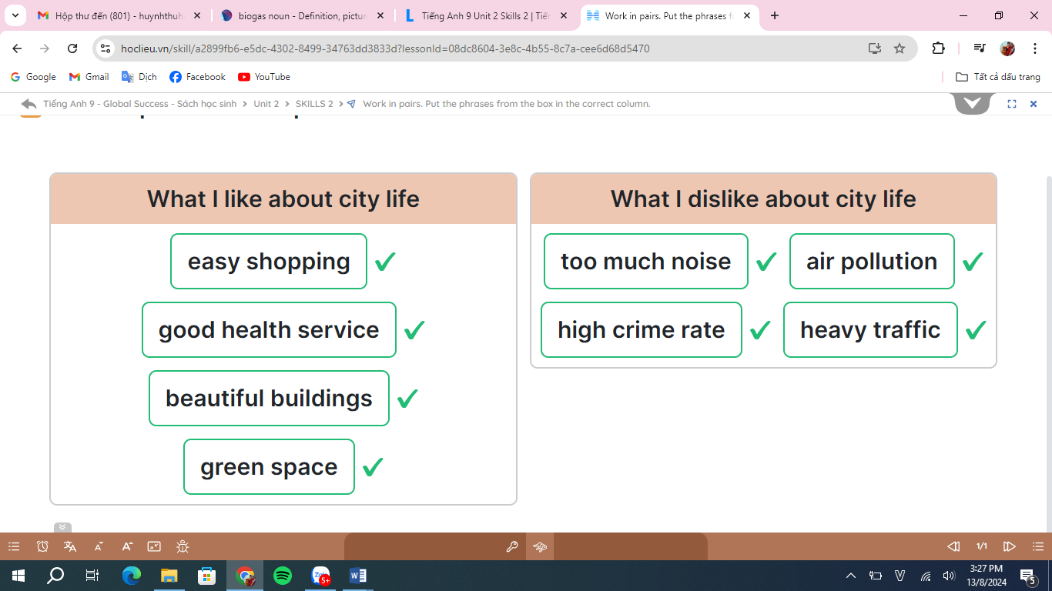
Act. 5: Write a paragraph (about 100 words) about what you like or dislike about living in a city. You can use the ideas in 4 or your own ideas.
- T asks Ss to work individually to write for 5 minutes. Tell them to use the information in 4 and any other ideas they may think of.
- T goes round and offers help if needed
- T asks some student to read aloud their writings to the class. Comment on their writings.
- Ss walk around and offer feedback on peers’ writing.
Sample paragraph:
I love city life. First, it is very convenient to live in the city. The public transport system reaches almost all areas of the city, so it is easy for me to get around. In addition, there are many shops that sell all kinds of goods, so I can buy almost everything I need. Second, the city often has many good schools and hospitals. Therefore, people here can enjoy quality education and healthcare. Finally, city life is exciting. There are many entertainment places for me and my friends. For example, we can hang out at shopping malls, watch movies at the cinema, and visit beautiful parks downtown.
In conclusion, I find the city a liveable place for me.
V. WRAP-UP:
*Aim: To consolidate what students have learnt in the lesson.
- T asks Ss to talk about what they have learnt in the lesson.
VI. HOMEWORK: - Learn by heart all the new words
- Do exercises again.
- Do exercises in the workbook.
- Prepare for Unit 2- Lesson 6: Skills 2.
* Feedback:
…………………………………………………………………………………………………………………………………………
…………………………………………………………………………………………………………………………………………
____________________________________
Week: 5  Period: 15 | UNIT 2: CITY LIFE  Lesson 7: Looking back and Project | DOP: 5/10/2025  DOT:
A. OBJECTIVES
By the end of this lesson, Ss will be able to:
I. Knowledge
- Review the vocabulary and grammar of Unit 2
- Apply what they have learnt (vocabulary and grammar) into practice through a project
II. Competences
- Apply their knowledge to do exercise
- Present their posters about a city in the future.
III. Personal qualities
- Be aware of city problems and their solutions
B. TEACHING AIDS
-Teacher: Grade 9 textbook, smart TV, visual aids, sachmem.vn
- Students: Textbooks, notebooks
C. PROCEDURES
I. WARM-UP (3 mins)
Aims: - To create an active atmosphere in the class before the lesson.
Brainstorming
- Teacher divides the board, and divides the class into teams.
- Members of each team take turns to write as many words about City as possible in 2 minutes.
- The group having more correct answers is the winner.
- Work in teams to play the games.
Suggested answers:
lively, suburbs, skyscraper, bustling, …..
II. PRE – STAGE: VOCABULARY (10 mins)
Aim: - To help Ss review the vocabulary of Unit 2.
Act. 1: Choose the correct answer to complete each sentence below. (5 mins)
- Have Ss do this activity individually then compare their answers with their partners.
- Ask for Ss’ answers or ask one student to write his / her answer on the board.
- Confirm the correct answers.
- Do the activity individually.
- Compare answers in pairs.
Answer key:
1. suburbs
2. metro
3. concrete jungle
4. lively
5. bustling
Act. 2: Fill in each gap with a word from the box to complete the passage. (5 mins)
- Have Ss read the passage and complete the blanks with the given words.
- Ask them to share their answers with a classmate.
- Invite some Ss to write the answers on the board. Confirm the correct answers.
- Ask Ss if they like or dislike Mia’s town.
- Do the task individually.
- Exchange their textbook to check the answers.
- Express one’s own opinion.
Answer key:
1. peaceful 2. safe
3. congestion 4. itchy
5. liveable
e. Assessment
- Teacher checks students’ answers as a whole class.
III. WHILE- STAGE: GRAMMAR (10 mins)
* Aims: To help Ss revise the double comparatives and some phrasal verbs.
- Recall the uses of the grammar that they have learnt in this unit (phrasal verbs and double comparatives).
Act. 3: Complete the sentences with the particles in the box. (5 mins)
T: - Ask Ss to list phrasal verbs they have learnt in the unit.
- Have Ss do this exercise individually then compare their answers with a partner. Call on some Ss to give the answers. Confirm the correct answers and write them on the board.
Ss: - Listen and review phrasal verbs.
- Do the exercise individually.
- Exchange their textbooks and give feedback to each other.
Answer key:
1. away
2. out
3. down on
4. out
5. down with
Act. 4: Find a grammar mistake in each sentence and correct it. (5 mins)
- Recall the structure of double comparatives Ss learnt in this unit.
- Tell them that they need to identify a grammar mistake in each sentence and correct it.
- Have Ss do this exercise individually then compare their answers with a partner.
- Invite some Ss to read their answers aloud. Confirm the answer keys.
- Listen and review double comparatives.
- Complete the task and discuss the answers.
Answer key:
1. more difficult → the more difficult
2. get up → get around*
3. Nearer → The nearer
4. came up with → came down with
5. more slow → slower
*Note:
go around = turn round in a circle
go around (to) = visit sb / a place that is near
get around = to go to a lot of different places
- Teacher corrects the students as a whole class.
IV. POST-STAGE: PROJECT (15 mins)
Aims: To help Ss improve their creativity and teamwork;
- To improve their speaking and presentation skills.
- Poster presentation
- Students are able to present their posters about a city in the future.
A city in the future
- As Ss have prepared for the project throughout the unit, the focus of this lesson should be on the final product, which is a poster presentation of future city.
- Have Ss work in their groups. Give them a few minutes to prepare for the presentation.
- Give Ss checklists for peer and self-assessment. Explain that they will have to tick appropriate items while listening to their classmates’ presentations and write comments if they have any.
- The presenters should complete their self-assessment checklists after completing their presentation. If necessary, go through the criteria for assessing their talk to make sure Ss are familiar with them.
- Invite the assigned groups to give their presentations. Encourage the rest of the class to ask questions at the end.
- Give praise and feedback after each presentation. T can summarise the feedback given by other Ss and add any other comments. T can also give Ss marks for their presentation as part of their continuous assessment.

Note: Assign the project in earlier lessons such as in COMMUNICATION lesson. Make sure you guide them carefully and check their progress after each lesson. In the last lesson (LOOKING BACK), ask Ss to present their report to the class.

NOW I CAN …
Ask Ss to complete the self-assessment table. Identify any diﬀiculties, weak areas, and provide further practice.
Ss -Work in groups to prepare for the presentation.
- Tick appropriate items while listening to their friends in the checklist.
Assessment
- Teacher gives corrections and feedback.
V. WRAP-UP (4 MINS)
*Aim: -To consolidate what Ss have learnt in the lesson
- Summarise the main points of the lesson.
VI. HOMEWORK
- Do exercises again.
- Do exercises in the workbook.
- Prepare for the next lesson: U.3 – GETTING STARTED
* Feedback:
…………………………………………………………………………………………………………………………………………………………………………

